Bill Fitzgerald DOB: May 20, 1925 [Highlights] July 4, 2020 Updated
Records: World, American, Championship Meet, and Meet Records [5 Year Age Brackets]
World Record: Bill Fitzgerald (44) 440 Yard at 52.3 (San Diego, July 1969)
World Record ? : Bill Fitzgerald (46) 400 m at 52.2 (Senior Games in L.A., June 19-21, 1971)
American Record ? : Bill Fitzgerald (44) 880 Yard at 1:59.8 (Gardena, June 24, 1969)
World Record ? : Bill Fitzgerald (45) 880 Yard at 2:01.4 (July 1970)
World Record ? : Bill Fitzgerald (46) 880 Yard at 2:00.9 (July 1971 National Outdoor Championship)
World Record ? : Bill Fitzgerald (47) 800 m at 1:58.4 (July 1-3, 1972 National Outdoor Championship)
World Record: Bill Fitzgerald (48) 800 m at 1:58.1 (July 6, 1973)
World Record: Bill Fitzgerald (50) 800 m at 2:01.1 (June 29, 1975 Senior Games in L.A.)
World Record: Bill Fitzgerald (55) 800 m at 2:08.9 (July 5, 1980)
World Record: Bill Fitzgerald (45) 1500 m at 4:13.6 (Los Angeles, June 20, 1970)
World Record: Bill Fitzgerald (47) 1500 m at 4:10.4 (Sept 14, 1972)
American Record: Bill Fitzgerald (50) 1500 m at 4:18.5 (June 28, 1975 Senior Games)
American Record: Bill Fitzgerald (55) 1500 m at 4:28.9 (July 12, 1980)
World Outdoor Record ? : Bill Fitzgerald (44) Mile at 4:28.0 (June 7, 1969 Compton-Coliseum in L.A.)
World Record ? : Bill Fitzgerald (45) Mile at 4:39.1 (May 2, 1971 Orange)
World Record ? : Bill Fitzgerald (46) Mile at 4:33.6 (July 3, 1971 San Diego)
World Record: Bill Fitzgerald (46) Mile at 4:29.5 (April 23, 1972)
World Record ? : Bill Fitzgerald (50) Mile at 4:37.1 (June 7, 1975 SCA / Fullerton)
World Record: Bill Fitzgerald (50) Mile at 4:32.2 (July 13, 1975 at Gresham, Oregon)
Current West Region Meet Record: Bill Fitzgerald (50) 800 m at 2:01.8 (1975)
Current West Region Meet Record: Bill Fitzgerald (50) 1500 m at 4:23.7 (1975)

Bill Fitzgerald at Masters US National Outdoor Championship:
1968 Outdoor Championship: M40-49: Age 43: 1st 440 Yard at 54.4 and 1st 880 Yard at 2:04.3 (July 1968)
1969 Outdoor Championship: M40-49: Age 44: 1st 440 Yard at 52.31, 1st 880 Yard at 2:14.1, and 1st Mile 4:37.0 (July 1969)
1970 Outdoor Championship: M40-49: Age 45: 880 Yard at 2:01.4 (July 2-5, 1970)
1971 Outdoor Championship: M40-49: Age 46: 440 Yard at 57.5, 1st 880 Yard at 2:00.9, 1st Mile at 4:33.6 (July 1971)
continued – next page

Bill Fitzgerald at Masters US National Outdoor Championship:- continued
1972 Outdoor Championship: M40-49: Age 47: 3rd 400 Meter at 52.9, 1st 800 Meter at 1:58.4, 3rd 1500 M at 4:14.3 (July 1972)
1973 Outdoor Championship: M40-49: Age 48: 2nd 800 m at 1:58.1 and 6th 1500 M at 4:12.1 (July 1973)
1974 Outdoor Championship: M40-49: Age 49: 2nd 800 m at 1:59.46 and 3rd at 1500 m at 4:12.82 (July 5-7, 1974)
1975 Outdoor Championship: M50-54: Age 50: 800 m at 2:03.8 (Aug 8-10, 1975)
1976 Outdoor Championship: M50-54: Age 51: 800 m at 2:04.34 and 1500 m at 4:18.53 (1976)
1976 – continued: Side note: ran with M40-44 group
1979 Outdoor Championship: M50-54: Age 54: 1st 800 m at 2:04.76 and 1st 1500 m at 4:21.94 (July 6-7, 1979)
1980 TAC Outdoor Championship: M55--59: Age 55: 1st 800 m at 2:08.9 and 1st 1500 m at 4:38.2 (TAC: July 4-6, 1980) Side Note: ran with the M40-49 group

Bill Fitzgerald at Masters Outdoor World Championship:
1975: M50-54: Age 50: 1st 800 m at 2:01.9 and 1st 1500 m at 4:23.4 (Aug 11-17, 1975 at Toronto)

Bill Fitzgerald at London, Helsinki, Stockholm, Gothenburg, and Germany:
1972: London: M40-49: Age 47: 1st 800 m at 2:00.5 (Aug 24-25, 1972)
1972: Helsinki: M40-49: Age 47: 1st 1500 m at 4:17.0 (Aug 1972)
1972: Stockholm: M40-49: Age 47: 1st 1500 m at 4:11.5 (Aug 1972)
1972: Gothenburg, Sweden: M40-49: Age 47: 1st 1500 m at 4:15.5 (1972)
1972: Cologne, Germany: Age 47: 2nd 800 m at 2:00.8 and 5th 1500 m at 4:10.4 (Sept 13-14, 1972)

Bill Fitzgerald at Senior Games (Olympics) Los Angeles:
1970 1st Ever Senior Games (Olympics) (which was held in LA): Age 45: 400 m at 52.2 and 1st 1500 m at 4:13.6 (June 19-21, 1970)
1971: M45-49: 1st 400 m at 52.2, 1st 800 m at 2:08.2 and 1st 1500 m at 4:42.5 (June 19-21, 1971)
1972: Senior Games in LA: M45-49: 2nd 400 m at 53.2, 1st 800 m at 2:06.5 and 1st 1500 m at 4:29.0 (June 17-18, 1972)
1980: Senior Games in LA: M55-59: Age 55: 1st 800 m at [?} and 1st 1500 m at 4:28.7 (July 12-13, 1980)

Bill Fitzgerald at Senior Games (Olympics) Irvine, Calif.:
1975: M50-54: Age 50: 1st 800 m at 2:01.1 and 1st 1500 m at 4:18.5 (June 28--29, 1975)
1976: M50-54: Age 51: 1st 800 m at 2:03.2 (June 27, 1976)

Bill Fitzgerald at Grandfather Games in LA:
1975: Grandfather Games: M40-49: 1st 800 m at 2:06.3 and 1st Mile at 4:38.4 (May 17-18, 1975)

Bill Fitzgerald at Masters SCA Championship:
1975: SCA: M50-54: Age 50: 1st 880 Yard at 2:07.2 and 1st Mile at 4:37.1 (June 7-8, 1975)
1980: SCA: M55-59: Age 55: 1st 800 m at 2:09.7 (June 7, 1980)
Bill Fitzgerald at Masters West Region Championship:
1975: West: M5-54: Age 50: 1st 800 m at 2:01.8 and 1st 1500 m at 4:23.7 (1975)
1980: West: M55-59: Age 55: 1st 800 m at 2:09.3 and 1st 1500 m at 4:28.9 (June 21-22, 1980)
Bill Fitzgerald at Masters Northeast Championship at Oregon:
1975: (50) 1st Mile at 4:32.2 (July 13, 1975 at Gresham, Oregon)

Bill Fitzgerald at Mt Sac Relays:
1976: (50) 1st Masters Mile at 4:24.8 (April 24-25, 1976)
Bill Fitzgerald at Pan AM Games:
1981: (56) 1st 400 m at 58.6, and 1st 800 m at 2:17.5 (Aug 8-9, 1981 in L.A.)

Bill Fitzgerald at Compton-Coliseum Invitation:
1969: Senior Mile: B. Gookin (36) 4:24.2, D. Waco (36) 4:26.6, B. Fitzgerald (44) 4:28.0, P. Mundle (41) 4:28.2, J. Van Tatenhove (39) 4:32.1 (Per June 8, 1969 Independent Press Telegram) (June 7, 1969 at Compton-Coliseum Meet) (Broke Mundle’s meet records of 4:30.0 from 1968)

Bill Fitzgerald at Mexico:
1976: (51): 800 m at 2:25.0 and 1500 m at 5:06.2 (Oct 21-26, 1976)

Bill Fitzgerald as Athlete of year:
1975: M50-54 Track and Field News Masters of the Year (5 year age bracket)
1976: M50-59 Calif. Athlete of Year (per Calif. Track News)
1980: M55-59 TAC Masters of the Year (5 year age bracket)

Bill Fitzgerald as Masters Hall of Fame:
2000: Elected to Masters Hall of Fame in 2000 (2000)

Information on Bill Fitzgerald per the Aug 1974 USMTT:

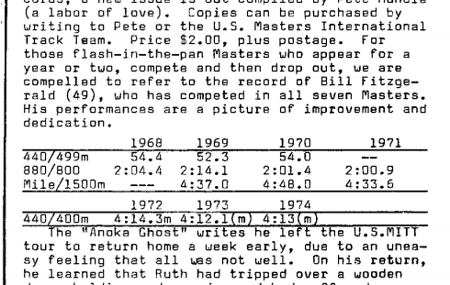

Information on Bill Fitzgerald per the July 1975 SFVTC newsletter:
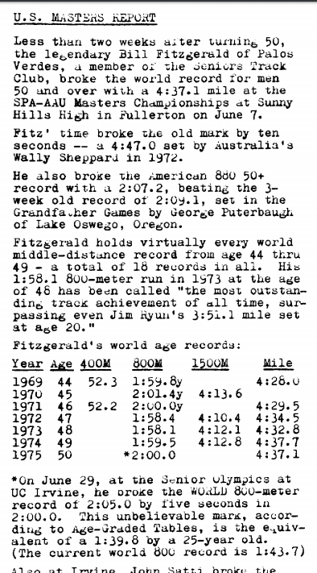

Information on Bill Fitzgerald per the 1970 Masters US National Outdoor Championship program:
