BIO Jeffery Davison (Jeff Davison) as of March 07, 2023 Page 1 of 2
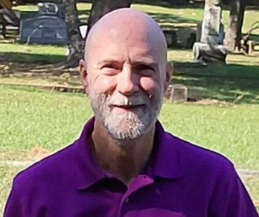 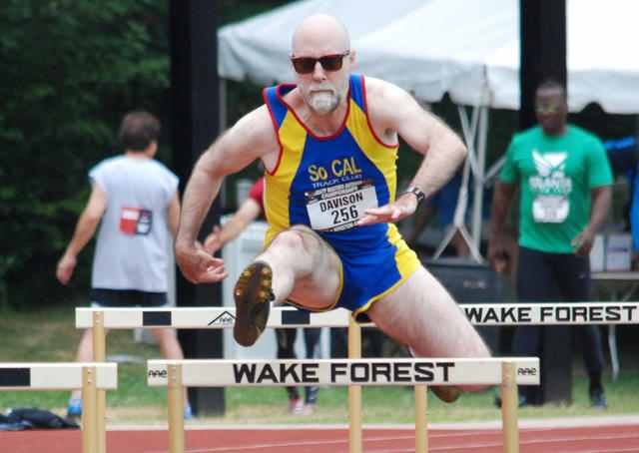
2022 (action pic by Stone Family: 2014 Shuttle Hurdle Relay event)
Focus outside of competing: Statistics, History, and Research (Athletics: Track and Field).
Athlete:
- Athletics (Track and Field) 1973 to 1982, and 2002 to Present; starting competing in Masters in 2002
- Hurdles: over 30 years of hurdling (1974 to 1982 and 2002 to Present)
- Varsity Letter: Freshman year in college (track and field) and senior year in high school (basketball and track and field)
- Basketball: competed one year in junior high school, and four years in high school
- Football: competed one year in Pop Warner football (during junior high school)
Records:
- Masters American Records in the Shuttle Hurdle Relay: M45 and M60 Club
- Held junior high school (that I attend) triple jump school record for one day
Unofficial Records:
- Unofficial records for the 42” 110 Meter High Hurdles for ages 57 and 60
- One of only four American athletes to compete in 42” 110 Meter Hurdle Race over the age 60
Awards:
- David Pain Award (USATF Masters Distinguished Services Award) in 2016
- Best Student Athlete: Senior Year on High School Basketball team
- MVP of the Smudge Pot Bowl: Pop Warner Football (tight end and defensive end) (during junior high school)
Author:
- Written Five sports statistics books: https://shr1.org/
- Written several short articles for National Masters News

Davison - continued
Volunteer Positions:
- Chair (Task Force Manager) of the Masters Track and Field History sub-committee: Dec. 2007 to Present
- Assisted with setting up hurdles at SCA Masters and West Region Masters meets for over 15 year each
- Assisted with Masters Track and Field HOF research
- Assist with compiling Masters Meet Records (SCA, West Region, and Striders MOC) since 2007
- Assisted organizing Shuttle Hurdle Relay teams for the Masters National Outdoor Championship: 2007 to present
- Shuttle Hurdle Relay: Assisted getting the Masters Shuttle Hurdle Relay recognized as an official event at the USA Masters T&F National Outdoor Championship (Dec 2010 USATF Convention) and get the event eligible for Masters American Records (Dec 2010 USATF Convention).

Website Designer:
- SHR1 https://shr1.org/
- Masters History https://mastershistory.org
- Shuttle Hurdle Relay https://shuttlehurdlerelay.com/
- woodhurdles http://woodhurdles.com/

Additional Athletics:
- Best Ranking (USA Masters Yearly Ranking):
Outdoor Sprint Hurdles (HH = High Hurdles) # 13 (twice) and # 14
Outdoor LH = Long Hurdles # 3, # 4 and # 8
Indoor Pent # 4 and # 9 Indoor Triple Jump # 12
- Best Placing at USA Masters T&F National Outdoor Championship: HH # 3 (2016); LH # 2 (2013)
- Best Placing at USA Masters T&F National Indoor Championship: Indoor Pent # 4 [2008]
- Best Placing at USA Masters T&F National Outdoor & Indoor Championship: First in Many Relays
- Shuttle Hurdle Relay – story-1 (External Link) and story-2 (External Link) and story-3 (External Link)
- Shuttle Hurdle Relay – story-4 (External Link) and story-5 (SHR: NMN July 2006, PDF: pg. 4 of 24)
Additional Non-Athletics:
- Career: Over 34 Years Estimator (Construction, Water & Waste Water Equipment, and Pressure Vessels)
- University: Bachelor and Masters Degrees
- Small Group Bible Study: Have led small group Bible studies for over 12 years

