Fred Norris Highlights
Long before there was the first “Masters Mile” (1966), and the first “Masters Track and Field National Championship” (1968) a British athlete was competing in his 40s. Fred Norris was a British Olympian at the 1952 and 1956 Olympics. In 1961 (freshman; age 39) and 1962 (sophomore; age 40) ran for McNeese State College in Louisiana. 1961 Fred Norris (39) of McNeese State in Louisiana ran a 4:21.0 mile (Mar 28, 1961) and 9:10.7 (May 13, 1961) two-mile (two-mile was a school record). 1961 Norris ran 1:20.14 for a 15-mile road race in Canada (a course record).
During the April 1961 Boston Marathon, Fred Norris assists John Kelley to his feet after Kelley was knocked down by a dog. Sept 4, 1961 Fred Norris turned 40. By the time Masters Track and Field Records were first published in the 1970s, Fred Norris was recognized as holding the M40 Mile, Two-Mile, Three-Mile, and Six-Mile World Records.
1962: While Norris competed at McNeese State College (Age 40):
Mar 24, 1962: Quad Meet: [McNeese vs Northwestern vs Southeastern vs Tulane] Fred Norris ran 4:27.6 mile and 9:34.5 two-mile at Natchitoches, Louisiana.
Mar 31, 1962: Quad Meet: [McNeese vs Northwestern vs Southeastern Louisiana vs Southwestern Louisiana] Norris ran a 4:32.2 mile and 9:50 two-mile. Poor weather conditions.
Apr 7, 1962: Triangular Meet (McNeese State vs Southeastern Louisiana vs Southwestern Louisiana) Norris 2nd in Mile (unknown time) and 9:15.9 two-mile at Lafayette, LA.
Per Apr 12, 1962: The Times, Shreveport: Norris season best was 9:15.9 two-mile.
Apr 14, 1962: Southwestern Relays: Norris ran a 9:09.4 two-mile breaking school record.
Apr 17, 1962: Triangular Meet [McNeese State vs Northwestern vs Southwestern Louisiana]
Norris ran 9:07.3 two-mile at Sulphur, LA. (Breaking school two-mile record)
Apr 20, 1962: Norris ran a 1:19:15 for 15-mile road race in Hamilton, Ontario.
Apr 28, 1962: Northwestern Relays: Norris 9:14.7 two-mile. Poor weather conditions.
May 2, 1962: Poor weather conditions, meet was cancelled.
May 12, 1962: Gulf States Conference Championship: Norris ran 9:07.8 two-mile (didn’t breaking school record, but set a new Gulf States Conference Championship meet record).
Per May 16, 1962 Lake Charles American-Press, LA: Norris season best were 4:21.9 mile and 9:07.3 two-mile.
Post McNeese days (Age 40 and 41):
June 24, 1962: Norris (40) wins 12.5 Miles in 1:05:08.2 at St Christopher’s Open
July 4, 1962: Norris (40) wins Senior 20 Kilometer in 63 minutes 12 seconds at Needham, MA (course record, beating John Kelley and Graham Parnell)
July 15, 1962: Norris runs 1:04.47 eight-Mile run at Mt Washington, NH
Jul 21, 1962 Norris (40) 29:26.0 for six-Miles at New London, Conn.
Jul 28, 1962: Norris (40) 2nd in 51:01 for 10-Mile road race at Lynn.
Aug 3, 1962: Norris (40) runs 56:58 (course record) for 10-Mile road race at Salem, MA
Aug 19, 1962: Norris (40) 2nd in 1:23:12 for 25 Kilometer run at New York
Sept 3, 1962: Fred Norris (40) (GBR) ran a 2:26:31 wining the Canadian Marathon Championship (beating John Kelly).
Sept 14, 1962: Norris (41) 48:45 wins 10-Mile road race in 48:45 at Dedham
Sep 25, 1962 Norris (41) 29:25 for six-Miles at New London, Conn.
Oct 13, 1962: Norris (41) wins race in Lancaster, England
Oct 14, 1962: Norris (41) wins 10-Mile race (course record) at Brockton, MA
Jun 12, 1963 Norris (41) runs a 14:23.0 three-Mile race at Hudson, NY
References:
- Lake Charles American-Press, LA: May 17 in 1961
- Lake Charles American-Press, LA: Mar 25, Apr 1, Apr 8, Apr 15, Apr 16, Apr 18, Apr 21, May 1, May 2, May 11, May 13, May 16, May 18, May 20 in 1962.
- Hartford Courant, Connecticut: Sept 4, 1962
- Daily Advertiser, Lafayette: Apr 8, 1962.
- The Times, Shreveport: Apr 12, 1962
- Boston Globe: Apr 19, Apr 20, July 5, July 16, July 29, Aug 4,, Aug 20, Sept 15, and Oct 15 in 1962.
- Press and Sun-Bulletin, Binghamton: June 25, 1962
- Post-Standard, Syracuse: Apr 21, 1962
- Track Newsletter: Dec 5, 1962
- Single Age Records: (Link)
- San Fernando Valley Track Club newsletter; May 1975: (Link)
- Wikipedia: (Wiki)

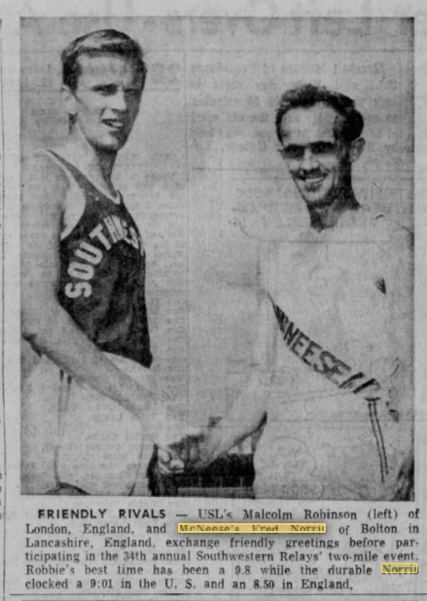
Picture: The Daily Advertiser, Lafayette: Apr 12, 1962 (Norris 8:50 & 9:01 were prior to 1962)

