1974 Masters National Decathlon Championship
Aug 2-3, 1974 at Hancock College in Santa Maria, Calif.
Results found in Aug 3 & 5, 1974 Santa Maria Times newspaper.
First Day Results:
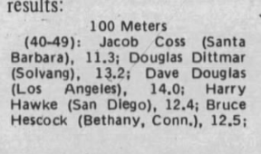
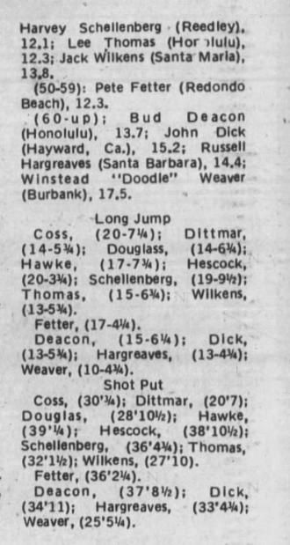
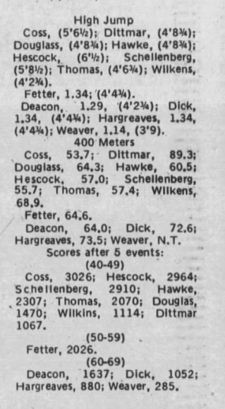
2nd Day Marks:
