1973 April Masters National Decathlon Championship in Hawaii
April 16-17, 1973 in Hawaii

Per Honolulu Advertiser April 17, 1973 for Day One
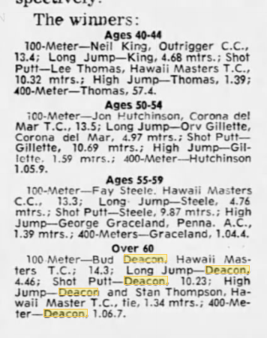

Per Honolulu Advertiser April 18, 1973 for Day Two
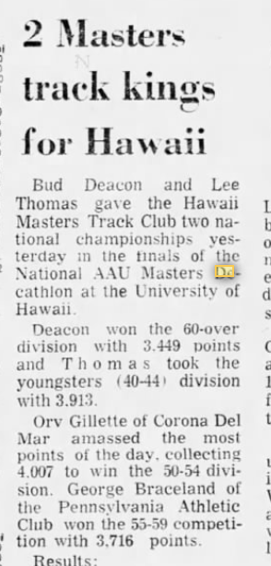

Per Honolulu Advertiser April 18, 1973 for Day Two
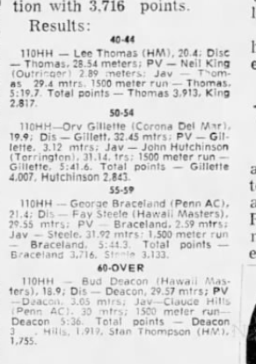

Per Honolulu Star Bulletin April 17 and 18, 1973 Day One
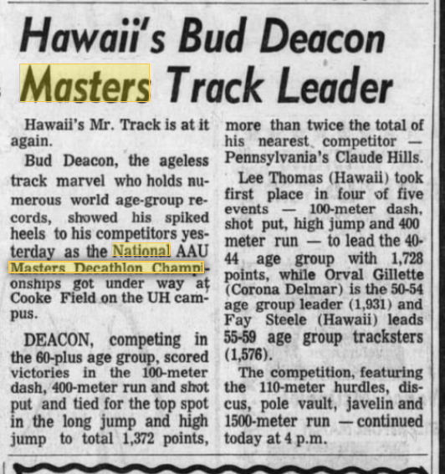

Per Honolulu Star Bulletin April 17 and 18, 1973 Day Two
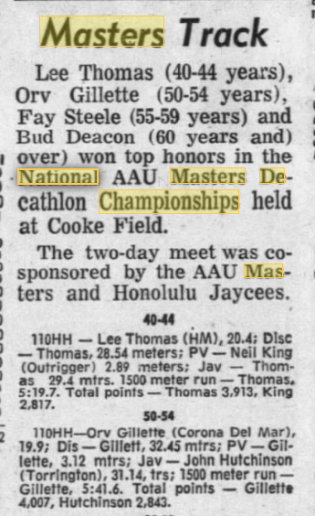

Per Honolulu Star Bulletin April 17 and 18, 1973 Day Two

